Gauguin, Paul (1848-1903)

Paul Gauguin was a Parisian-born French artist who was for a time associated with the Neo-Impressionist and Symbolist movements in painting. Having turned to a career as an artist relatively late, after working as a stockbroker, he became a remarkable presence within the French avant-garde. His activities as an artist fall, broadly, into two professional phases. The first phase of Gauguin’s career is characterised by his work in France up until 1891. During this early part of his career, he became closely linked to the Neo-Impressionist circle and learned his technical practice from painters such as Camille Pissaro (1830-1903). Later on in this period, he famously became acquainted with Vincent van Gogh (1853-1890) in a tumultuous and short-lived professional relationship. Towards the end of this phase of activity in France, he became involved with the Symbolist movement through his friendship with the poet Charles Morice (1860-1919). The second phase of Gauguin’s career is characterised by his activities in French Polynesia, where, from 1891 until his death in 1903, he sought to develop a primitivist approach to art based on Polynesian traditions. During this later period, he also produced a significant body of writing on art and his travels.

Paul Gauguin worked in close proximity to various artistic movements and numerous celebrated artists during his career in France. In 1879, he was invited by Camille Pissaro and Edgar Degas (1834-1917) to exhibit in the Fourth Impressionist Exhibition in Paris. Through this invitation Gauguin established himself among the Neo-Impressionist circle in the early 1880s. He developed a close relationship with Pissaro in particular, and the older artist mentored him for several years. In the summer of 1886, after his family relationship with his wife Mette and their children had broken down, Gauguin travelled to Pont-Aven in Brittany, where he became immersed in another community of artists. Owing to his connections in the Parisian avant-garde, Gauguin was received with some celebrity in the small estuary-port town. He had soon attracted a group of young and enthusiastic painters around him who would become notable artists in their own right. Among this group were: Charles Laval (1862-1894), with whom Gauguin travelled to Martinique in 1887; Emile Bernard (1868-1941); and Paul Sérusier (1864-1927). In late 1887, after exhibiting paintings from his trip to Martinique in Paris, Gauguin secured Theo van Gogh, the brother of Vincent Van Gogh, as his art dealer. Having been introduced to Vincent by Theo, Gauguin entered into a correspondence with the artist over the following year, which led to Gauguin visiting Vincent at his ‘Yellow House’ in Arles, France, in 1888.

By the early 1890s, before his trip to Tahiti, Gauguin had earned a reputation among a group of critics and writers associated with Symbolism. In particular, he had received special attention and praise in Gabriel-Albert Aurier’s text *Le Symbolisme en Peinture* [*Symbolism in Painting*, 1891]. Around this time Gauguin developed what might loosely be labelled as a ‘Symbolist’ approach to painting, whereby he prioritised mysterious and ambiguously suggestive imagery over naturalistic and descriptive representation. Several years later, however, Gauguin expressed his distance from popular Symbolist theory, criticizing many Symbolist theorists in his notes *Diverse Choses* (*Diverse Things*), 1896-7.

Throughout his career, Gauguin consistently pursued his conception of a primitive subject, anterior to the advanced civilization of modernised Europe. It was this interest that led him to Brittany, Martinique, Tahiti and the Marquesas Islands. His pronounced interest in ‘primitive’ culture casts a long shadow down the history of modernism; primitivism remained a strong interest within the Parisian avant-garde for many years after his death. His primitivist interest also informed the aesthetic effect of his work. The flat and decorative qualities of his painterly style were closely derived from his experience of so-called ‘primitive’ art. From carved wooden panels in Brittany to tribal tattooing and sculpture in Polynesia, he found aesthetic precedent for his work. These formal traits in Gauguin’s work have positioned him securely within the traditional narrative of modernism’s development, in terms of a growing concern with pictorial flatness and the material properties of paint.

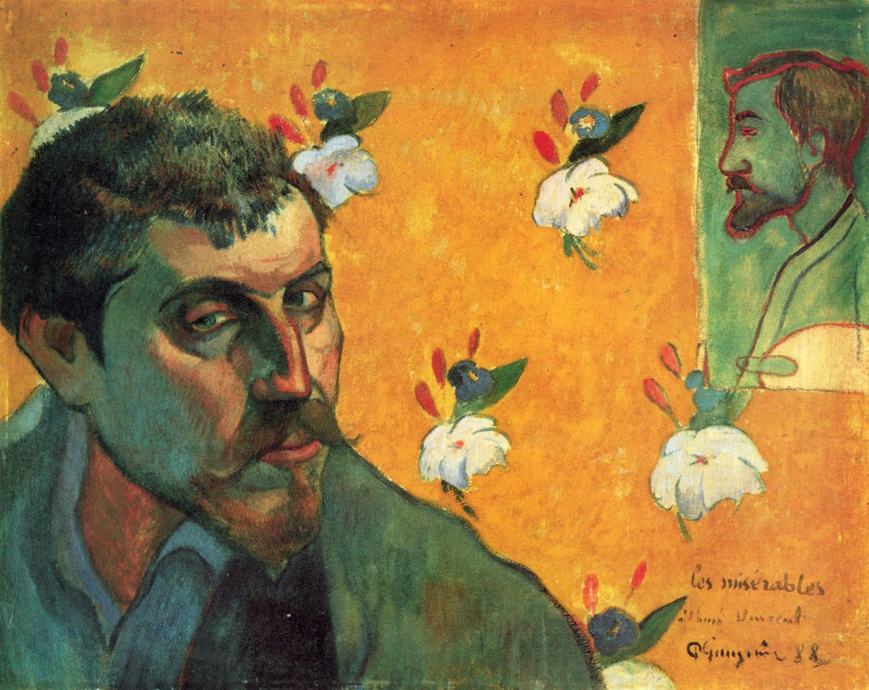

\**Self-Portrait, Les Misérables,* (1888), Van Gogh Museum, Amsterdam.

<http://www.vangoghmuseum.nl/vgm/index.jsp?page=4757&lang=en>

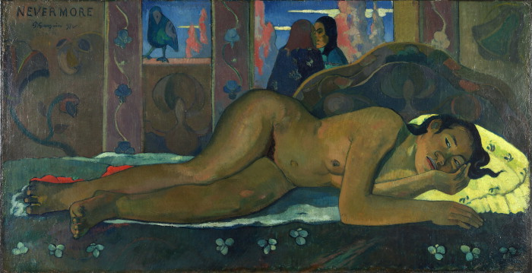

\**Nevermore,* (1897), The Courtauld Gallery, London. <http://www.artandarchitecture.org.uk/images/gallery/9b970750.html>

References and Further Reading

Guérin, Daniel (ed.), *The Writings of a Savage: Paul Gauguin*, trans. Eleanor Levieux, (New York: Viking, 1978).

Thomson, Belinda (ed.), *Gauguin: Maker of Myth*, (London: Tate, 2010).

Vargas Llosa, *The Way to Paradise*, (London: Faber and Faber, 2004).

Wildenstein, Daniel, *Gauguin: Catalogue Raisonné of the Paintings*, Vols 1 & 2, (Skira, 2002).